Adam Elder and Robert Young

COSC326 Etude 11

21/3/17

Heads and Tails

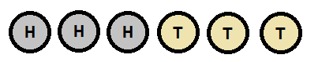 Given three heads followed by three tails in a line, the task is to find the minimum number of moves needed to alternate the heads and tails. A ‘move’ consists of swapping two adjacent coins.

Our solution for finding the minimum number of moves need involves two distinct phases:

1. Get the leftmost coin to be either heads or tails, depending on which one has the greater quantity in the scenario. If there is the same number of heads as tails, this step does not matter. The only time anything will need to be done is when there are more tails than heads, as the leftmost tail will need to be moved over to the leftmost position overall. If this is the case, this step will cost n moves, where n is the number of heads, as the leftmost tail will need to swap places with each one.
2. Move along the sequence from left to right and find the first possible coin swap that will separate two identical coin types. Swap those coins and move back to the start of the sequence. Repeat this step until the coins are alternating.

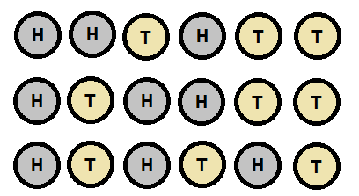Our solution in can solve the three heads/three tails problem in three moves:

Because there is the same number of heads as tails, we can skip the first step of our solution. Moving from left to right, we can see that swapping the 3rd and 4th coins will separate the 2nd and 3rd coins, which are both heads. Two more swaps like this one will have the leave us with an altering sequence of heads and tails across all coins.

Now we can try our solution on cases where the number of heads doesn’t equal the number of tails.